**Program 31: Create an abstract class named as "Bike" that contains two abstract methods named as maxspeed () and average (). Create three classes for bike splendor, Royal Enfield class 350 and KTM and these classes are inheriting the "Bike" class. Write a program to display bike details with maximum speed and average of a bike.**

**Code:**

|  |
| --- |
| using System;  namespace fourth_practical  {  public abstract class Bike  {  public abstract void Average();  public abstract void maxSpeed();  }  public class Splendor : Bike  {  public override void Average()  {  Console.WriteLine("Splendor Average is 50-60 km/h");  }  public override void maxSpeed()  {  Console.WriteLine("Splendor max speed is 70-80 km/h");  }  }  public class RoyalEnfield350 : Bike  {  public override void Average()  {  Console.WriteLine("Royal Enfield classic 350 Average is 25-35 km/h");  }  public override void maxSpeed()  {  Console.WriteLine("Royal Enfield classic 350 max speed is 110-120 km/h");  }  }  public class KTM : Bike  {  public override void Average()  {  Console.WriteLine("KTM Average is 25-35 km/h");  }  public override void maxSpeed()  {  Console.WriteLine("KTM max speed is 150-160 km/h");  }  }  public class Program  {  public static void Main(string[] args)  {  // Splendor  Splendor splendor = new Splendor();  splendor.Average();  splendor.maxSpeed();  // Royal Enfield 350  RoyalEnfield350 royal = new RoyalEnfield350();  royal.Average();  royal.maxSpeed();  //KTM  KTM ktm = new KTM();  ktm.Average();  ktm.maxSpeed();  }  }  } |

**Output:**

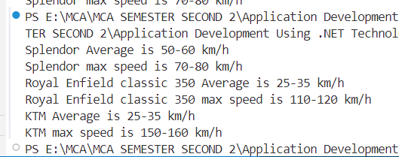

**Program 32: Take mth row and nth column from user and declare a 2-D array with elements through user input. Write a program:**

* **To display array in such a way that 1st column become 1st row, 2nd column become 2nd row and as follows if m is equivalent to n.**
* **To display the addition of each column of an array if m is greater than n.**
* **To display the addition of each row of an array if mis less than n.**

**Code:**

|  |
| --- |
| using System;  class Program  {  static void Main()  {  Console.Write("Enter number of rows (m): ");  int m = Convert.ToInt32(Console.ReadLine());    Console.Write("Enter number of columns (n): ");  int n = Convert.ToInt32(Console.ReadLine());    int[,] array = new int[m, n];    Console.WriteLine("Enter array elements:");  for (int i = 0; i < m; i++)  {  for (int j = 0; j < n; j++)  {  Console.Write("Element [{0},{1}]: ", i, j);  array[i, j] = Convert.ToInt32(Console.ReadLine());  }  }    if (m == n)  {  Console.WriteLine("\nTransposed Matrix:");  for (int i = 0; i < n; i++)  {  for (int j = 0; j < m; j++)  {  Console.Write(array[j, i] + " ");  }  Console.WriteLine();  }  }  else if (m > n)  {  Console.WriteLine("\nColumn-wise Sum:");  for (int j = 0; j < n; j++)  {  int sum = 0;  for (int i = 0; i < m; i++)  {  sum += array[i, j];  }  Console.WriteLine("Sum of column {0}: {1}", j + 1, sum);  }  }  else  {  Console.WriteLine("\nRow-wise Sum:");  for (int i = 0; i < m; i++)  {  int sum = 0;  for (int j = 0; j < n; j++)  {  sum += array[i, j];  }  Console.WriteLine("Sum of row {0}: {1}", i + 1, sum);  }  }  }  } |

**Output:**

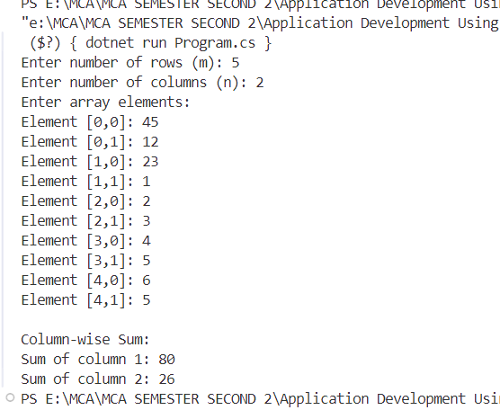

**Program 33: Write a program to create a class name as "Convert" that contains data members as follows:**

* **name: String**
* **show, (string): Display the string in such a way that if a character is a vowel, show the second previous character, and if the character is not a vowel, show the second next character.**

**Note: Use of this keyword is compulsory, and you cannot create object in this program.**

**Example: name "Kavita danu" Resultant string- Myxgyy fyps**

**Code:**

|  |
| --- |
|  |

**Output:**

**Program 34: Write a program to check which string is greatest out of two, three, and four string by using function overloading.**

**Code:**

|  |
| --- |
|  |

**Output:**

**Program 35: Create a C# program where you have a base class 'Shape' with a virtual method called Calculate Area () that returns the area of a shape. Then, create derived classes 'Circle' and 'Rectangle' that inherit from 'Shape' and override the CalculateArea () method to calculate the area of a circle and rectangle respectively, based on their specific properties like radius and length/width.**

**Code:**

|  |
| --- |
|  |

**Output:**